Mobile Digital Video Recorder
User Manual

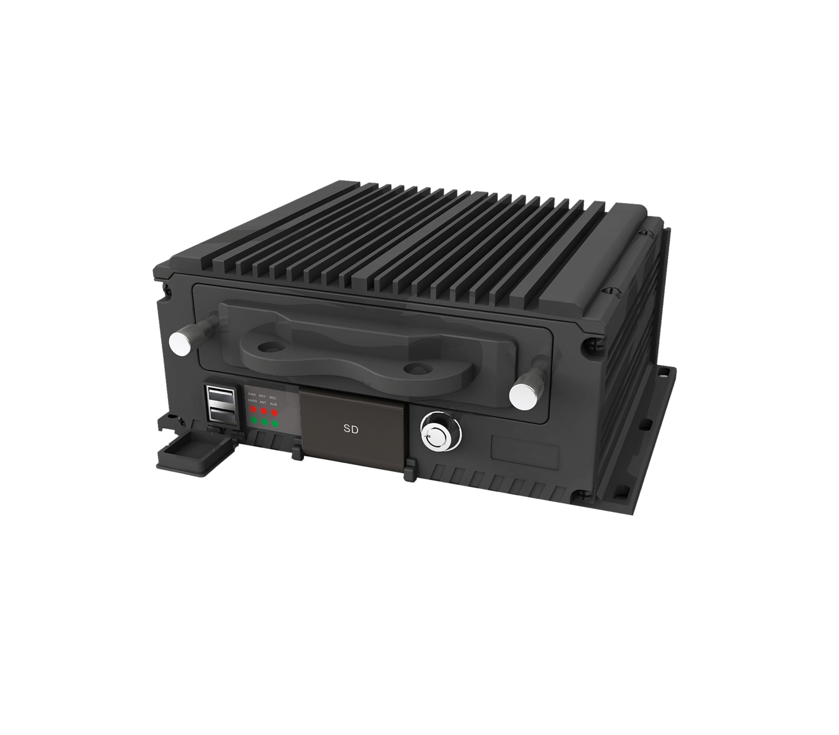

Ver 2.0

User Manual
About this Manual
This Manual is applicable to Mobile Digital Video Recorder.
The Manual includes instructions for using and managing the product. Pictures, charts, images and all other information
hereinafter are for description and explanation only. The information contained in the Manual is subject to change, without
notice, due to firmware updates or other reasons. Please find the latest version in the company website.
Please use this user manual under the guidance of professionals.

Legal Disclaimer
TO THE MAXIMUM EXTENT PERMITTED BY APPLICABLE LAW, THE PRODUCT DESCRIBED, WITH ITS
HARDWARE, SOFTWARE AND FIRMWARE, IS PROVIDED “AS IS”, WITH ALL FAULTS AND ERRORS, AND
OUR COMPANY MAKES NO WARRANTIES, EXPRESS OR IMPLIED, INCLUDING WITHOUT LIMITATION,
MERCHANTABILITY, SATISFACTORY QUALITY, FITNESS FOR A PARTICULAR PURPOSE, AND
NON-INFRINGEMENT OF THIRD PARTY. IN NO EVENT WILL OUR COMPANY, ITS DIRECTORS, OFFICERS,
EMPLOYEES, OR AGENTS BE LIABLE TO YOU FOR ANY SPECIAL, CONSEQUENTIAL, INCIDENTAL, OR
INDIRECT DAMAGES, INCLUDING, AMONG OTHERS, DAMAGES FOR LOSS OF BUSINESS PROFITS,
BUSINESS INTERRUPTION, OR LOSS OF DATA OR DOCUMENTATION, IN CONNECTION WITH THE USE OF
THIS PRODUCT, EVEN IF OUR COMPANY HAS BEEN ADVISED OF THE POSSIBILITY OF SUCH DAMAGES.
REGARDING TO THE PRODUCT WITH INTERNET ACCESS, THE USE OF PRODUCT SHALL BE WHOLLY AT
YOUR OWN RISKS. OUR COMPANY SHALL NOT TAKE ANY RESPONSIBILITES FOR ABNORMAL OPERATION,
PRIVACY LEAKAGE OR OTHER DAMAGES RESULTING FROM CYBER ATTACK, HACKER ATTACK, VIRUS
INSPECTION, OR OTHER INTERNET SECURITY RISKS; HOWEVER, OUR COMPANY WILL PROVIDE TIMELY
TECHNICAL SUPPORT IF REQUIRED.
SURVEILLANCE LAWS VARY BY JURISDICTION. PLEASE CHECK ALL RELEVANT LAWS IN YOUR
JURISDICTION BEFORE USING THIS PRODUCT IN ORDER TO ENSURE THAT YOUR USE CONFORMS THE
APPLICABLE LAW. OUR COMPANY SHALL NOT BE LIABLE IN THE EVENT THAT THIS PRODUCT IS USED
WITH ILLEGITIMATE PURPOSES.
IN THE EVENT OF ANY CONFLICTS BETWEEN THIS MANUAL AND THE APPLICABLE LAW, THE LATER
PREVAILS.

Safety Instruction

These instructions are intended to ensure that user can use the product correctly to avoid danger or property loss.

The precaution measure is divided into “Warnings” and “Cautions”

Warnings: Serious injury or death may occur if any of the warnings are neglected.

Cautions: Injury or equipment damage may occur if any of the cautions are neglected.
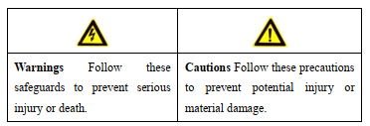



Warnings

● Proper configuration of all passwords and other security settings is the responsibility of the installer and/or end-user.

● In the use of the product, you must be in strict compliance with the electrical safety regulations of the nation and region.

Please refer to technical specifications for detailed information.

● Input voltage should meet both the SELV (Safety Extra Low Voltage) and the Limited Power Source with +9 to +32

VDC according to the IEC60950-1 standard. Please refer to technical specifications for detailed information.

● Do not connect several devices to one power adapter as adapter overload may cause over-heating or a fire hazard.

● Please make sure that the plug is firmly connected to the power socket.

● If smoke, odor or noise rise from the device, turn off the power at once and unplug the power cable, and then please
contact the service center.
➢ Read, keep and follow these instructions.
➢ Professional automobile assembly manufacturers or automakers are required for the system installation. And place the
device at a well-ventilated position inside the automobile.
➢ Please make yourself be familiar with the power connection before installation.
➢ Install antennas of wireless networks and satellite positioning in place with good signal and away from lightning,
avoiding the coverage or shielding of other objects. Keep the master and slave antennas upright in a distance of at least
20cm if both of them are installed.
➢ The system is made of sophisticated electronics and do not disassemble the device by yourself.
➢ Contact the qualified technician from manufacturer or authorized dealer if there is any question or request.

TABLE OF CONTENTS
Chapter 1 Product Introduction 5
1.1 Product Overview 5
1.1.1 Product Key Features 5
1.2 Panel Introduction 6
Chapter 2 Device Installation 10
2.1 Installation precautions 10
2.2 Installation environment 10
2.3 SSD Installation 11
2.3 SD Card Installation 13
2.4 SIM Card Installation 14
Chapter 3 Wiring instructions 15
3.1 Power wiring 15
3.1.1 Delayed shutdown 15
3.1.2 Timer switch 16
3.2 Alarm input 17
3.3 Alarm output 17
3.4 Sensor-In 18
Chapter 4 System Login 19
4.1 System Login 19
4.2 System Logout 19
Chapter 5 Record and Playback 20
5.1 Configuring Record 20
5.1.1 Format storage device 20
5.1.2 Configuring Record Plan 21
5.2 Playback 21
5.3 Video Backup 23
Chapter 6 Vehicle Configuation 24
6.1 Delayed shutdown 24
6.2 Timing start 24
6.3 GPS configuration 25
6.4 Configuring G-Sensor 26
6.5 Sensor-In Configuring 27
Chapter 7 Network Configuration 28
7.1 Network Connection 28
7.1.1 Wireless connections 28
7.1.2 Wired Connection 29
7.2 Remote access 29
7.3 Port Configure 30
Chapter 8 Channel Management 31
8.1 Video and Audio Settings 31
8.2 Display settings 32
8.3 PTZ Settings 32
8.3.1 PTZ Operate 32
8.3.2 Preset point operation 34
8.3.3 Cruise scan operation 34
Chapter 9 Event Configuration 36
9.1 Video loss alarm configuraton 36
9.2 Alarm input configuraton 37
9.3 Alarm Output Configuraton 38
Chapter 10 Security Management 39
10.1 User Management 39
Chapter 11 Maintenance Management 40
11.1 View device information and logs 40
11.1.1 View device information 40
11.1.2 Log query 40
11.2 Upgrade, restart, restore factory settings 41
11.2.1 Upgrade 41
11.2.2 Restart 41
11.2.3 restore factory settings 41
11.3 Time Setting 42
11.4 Resolution setting 42
Appendix 43
Abbreviations 43
FAQ 43

Chapter 1 Product Introduction

1.1 Product Overview
Mobile DVR (DVR for short) is a car video and audio monitoring product using embedded Linux operating system.
It has functions such as video and audio codec, 3G/4G network transmission, satellite positioning, data security storage,
etc., and provides flexible channel selection and coding schemes. ...
Due to its characteristics, DVR can be widely used in the video and audio monitoring scenes of various buses,
passenger buses, school buses and other vehicles.

1.1.1 Product Key Features

● 4ch/8ch of analog video and audio input, each channel up to 1080P encoding, standard H.265 stream, supports dual stream;
● With 1ch CVBS video output, 1ch audio output;
● With 1ch VGA video output interface, max resolution up to 1920*1080;
● Brand-new in-vehicle dedicated GUI interface, with good user experience, and supports WEB login, Easy to operate;
● It can access 1*M2 SSD and 1*SD card simultaneously (SD card as a spare hard disk), it is pluggable;
● Built-in 3G/4G wireless module, providing flexible wireless transmission;
● ● With USB data export interface;
● ● Built-in high-sensitivity satellite positioning module, supporting extended BDS (Beidou positioning), positioning information
synchronously encapsulated into the video stream;
● With information collection interface, it can collect the driver's turn left, turn right, brake, reverse, etc;
● ● The main interface adopts the special aviation plug for vehicle to ensure the stable signal connection;
● ● With delayed shutdown (0 minute to 6 hours) and 24-hour timing switch function;
● ● Wide range power supply (DC +9V to +36V), meet the requirements of vehicle electrical characteristics;
● ● Aluminum stretch case, with good adaptability to vehicle working environment;
● ● Support left and right mirroring of reversing camera.

1.2 Panel Introduction

Front Panel

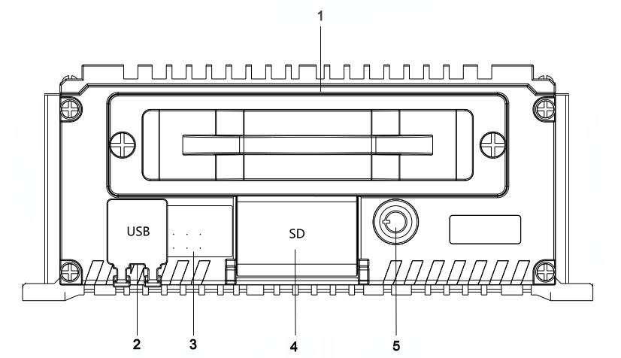

Figure 1-1 Front Panel

NO. | Name | NO. | Name
1 | SSD | 3 | ALM:Alarm indicator
2 | USB 2.0 interface | 3 | ANT:Dialing indicator
4 | SD card slot | 3 | GNSS:GPS indicator
5 | SSD lock | 3 | REC:Record indicator
 |  | 3 | RDY:Ready indicator
 |  | 3 | PWR:Power indicator

Table 1-1 Description of Front Panel

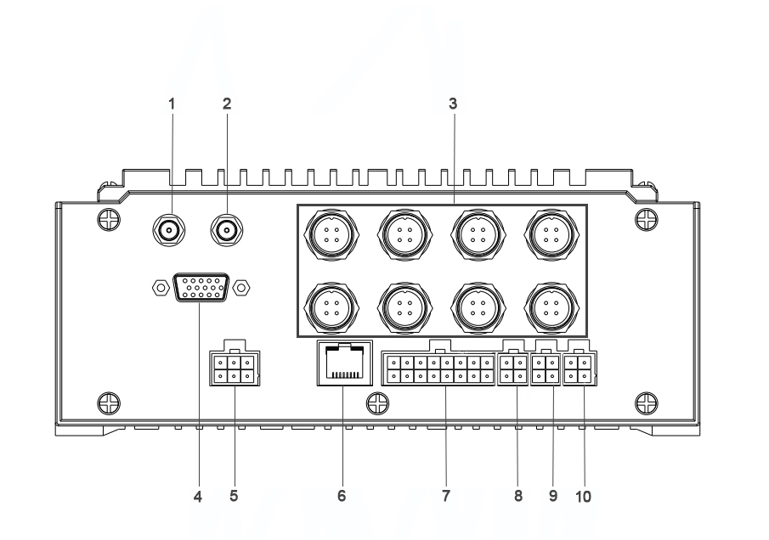
Rear Panel

Figure 1-2 Rear Panel

NO. | Name | NO. | Name
1 | GNSS:GNSS antenna interface | 6 | Network interface
2 | 3G/4G:3G/4G antenna interface | 7 | I/O:ALARM IN,ALARM OUT,and sensor-in
3 | Anglog camera inputs:1-4CH,5-8CH  ( Please refer to the actual device) | 8 | NC
4 | VGA | 9 | RS-232 interface
5 | Power supply | 10 | EXT.DEV:two-way audio interface,  and CVBS video output

Table 1-2 Description of Rear Panel

DVR provides AV1-AV1 or AV1-AV8 Audio/video input, and the connector is a professional aviation connector, which is suitable for use in the harsh environment of the car.
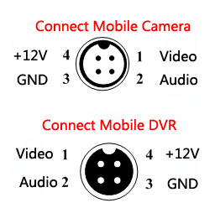

DVR Aviation head interface definition:

Camera Aviation head interface definition:

Figure 1-3 Audio/Video Interface definition

The definition of the power input pins on the rear panel of the DVR is as shown in the diagram below:

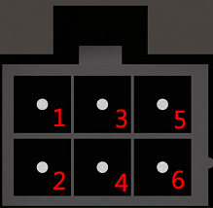
Description of DVR power inpiut interface

1 | 3 | 5
POWER+ | POWER+ | ACC
2 | 4 | 6
POWER- | POWER- | POWER-

Figure 1-4 DVR power input interface Table 1-3 Description of DVR power inpiut interface

The detailed definitions of the 16PIN and 3*4PIN extension ports are as follows:
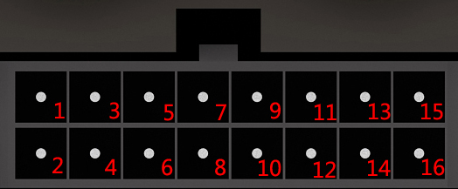

Figure 1-5 DVR 16PIN I/O Interface
Description of DVR 16PIN I/0 interface
1 | 3 | 5 | 7 | 9 | 11 | 13 | 15
OUT2+ | OUT1+ | GND | GND | ALM4 | ALM2 | SEN4 | SEN2
2 | 4 | 6 | 8 | 10 | 12 | 14 | 16
OUT2- | OUT1- | GND | GND | ALM3 | ALM1 | SEN3 | SEN1
Table 1-4 Description of DVR 16PIN I/0 interface

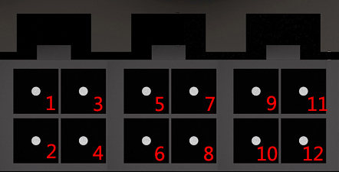

Figure 1-6 DVR 3*4PIN Expand Interface
Description of DVR 3*4PIN Expand Interface
1 | 3 | 5 | 7 | 9 | 11
NC | NC | RX | TX | GND | GND
2 | 4 | 6 | 8 | 10 | 12
NC | NC | GND | 12V | AUDIO | CVBS

Table 1-5 Description of DVR 3*4PIN Expand Interface

Chapter 2 Device Installation

2.1 Installation precautions

Basic requirements for installation
● 1.All electrical work must comply with the latest electrical regulations, fire protection regulations and related regulations in the place of use.
● 2.Be sure to turn off the power of all related equipment during installation.

Cable requirements
1. It is recommended that the installation cable is in the same direction as the original vehicle cable, and the wiring shall be installed along the original trunking of the vehicle and bound and fixed with the original vehicle cable.
● 2.The wiring must be neat and concealed to prevent the driver and passengers from breaking.

2.2 Installation environment

Preparation before installation
Take the device out of the package, check that the device and accessories are not damaged or missing, and then start to install the device.
● 1.This article takes 1 model as an example for installation description. Each appearance and size may be different, please refer to the actual device.
● 2.When disassembling, connecting, etc., be sure to disconnect the power supply, and do not perform live operations.

Environmental requirements
Before the DVR is installed, it is necessary to carry out the deployment reconnaissance and planning of the installation location and wiring to ensure the safety and stability of the power supply and wiring. At the same time, the convenience and rationality of wiring need to be considered.
1. Anti-vibration: Choose a place with weak vehicle vibration (such as behind the driver's seat or behind the co-driver's seat), away from the engine.
● 2.Heat dissipation: Ensure that the device is far away from the heat source on the vehicle and installed in a well-ventilated location to facilitate heat dissipation.
● 3.Space: Reserve space for air circulation, heat dissipation, and hard disk box insertion and removal, as shown in Figure 2-1.
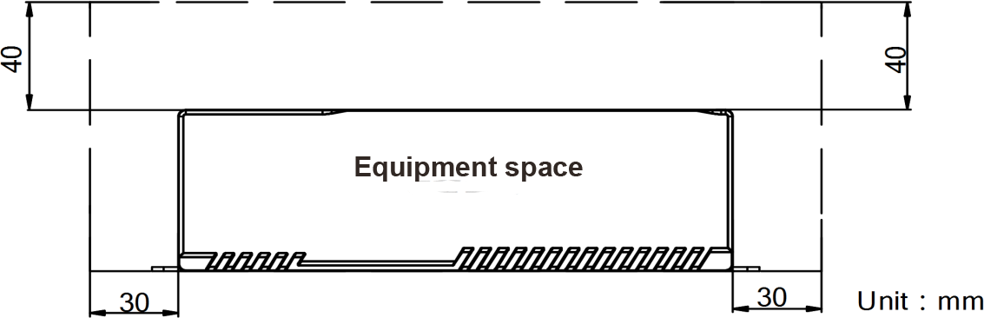

Figure 2-1 Reserve equipment space
● 4.Placement angle: Place the forensic host horizontally. Any other angle installation method may damage the equipment.
● 5. Fixing: It is recommended to use the national standard M4 combination screws to fix it. All fixing screws must be fastened in place to avoid loosening after long-term driving bumps and causing the DVR to fall.

2.3 SSD Installation

Use the factory recommended M.2 SSD.
Format the SSD for recording after the installation. For details, see 4.1.1 Formatting Storage Device.
Perform the following steps to install the SSD on the mobile DVR.
Before you start:
Prepare the tools and components for installation: M.2 SSD, antistatic gloves, key of hard disk lock, cross
screwdriver, and screws.
Steps:
1. Put on the antistatic gloves before the installation.
2. Insert the key and anticlockwise rotate it to unlock the SSD lock.

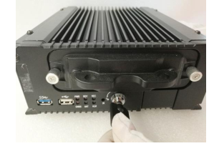

Figure 2-2 Unlock SSD lock
3. Loosen the screws on the SSD portable cover with a screwdriver counterclockwise, and pull out the SSD handle cover.
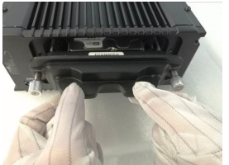

Figure 2-3 Pull out the ssd handle cover

4. Insert the hard drive into the hard drive bracket in the direction of the arrow, and push it into the hard drive socket with appropriate force.
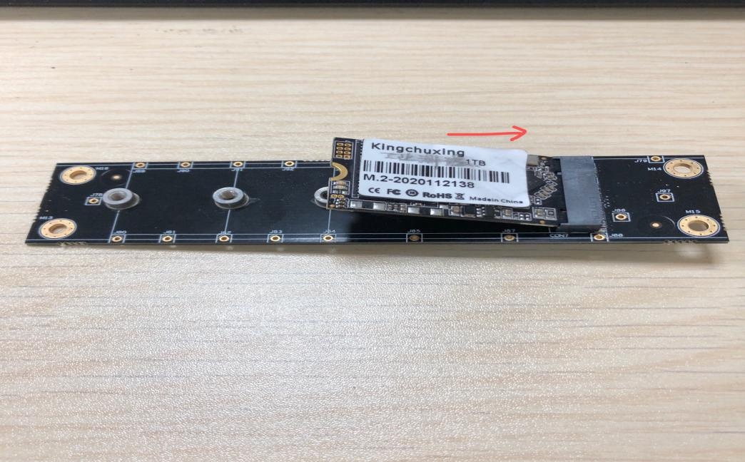
Figure 2-4 Insert SSD

5. Screw in a countersunk screw to fix the SSD.

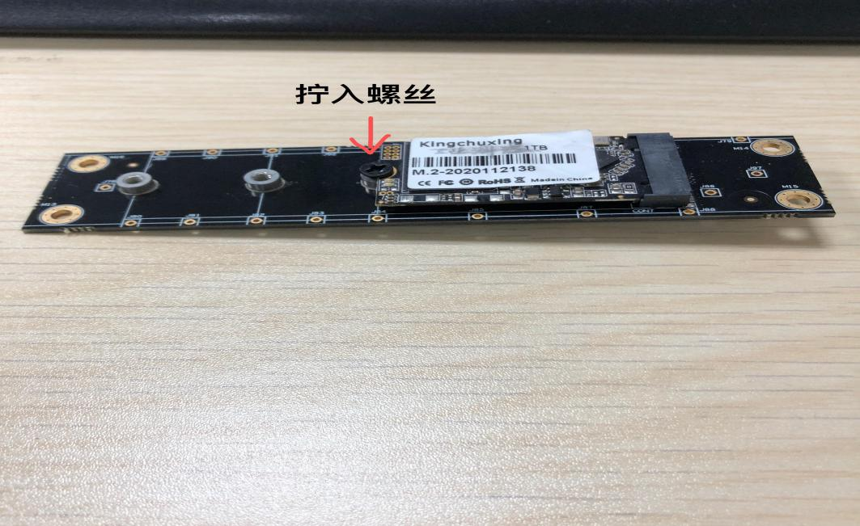
Figure 2-5 Fixed SSD

6. Install the SSD handle cover, Tighten the 2 fixing screws clockwise

7. Rotate the SSD lock key 90° clockwise to lock complete the installation

2.3 SD Card Installation

Purpose:
SD card with capacity up to 128 G can be installed.
Before you start:
Prepare the tools and components for installation: factory recommended SD card, antistatic gloves, and key of SSD
lock.
Steps:
1. Put on the antistatic gloves before the installation.
2. Insert the key and anticlockwise rotate it to unlock the SSD lock.
3. Unfasten the two screws in SSD handle cover anticlockwise and pull out the SSD handle cover.

Figure 1. 14 Pull Out Hard Disk Box
4. Open the cover of SD card slot.
5. Insert the SD card into the slot with the golden contact facing downwards and the tringle-shaped notch facing right.
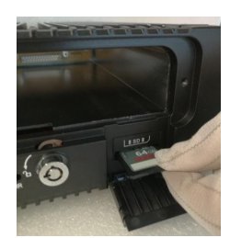

Figure 1. 15 Insert SD Card
6. Close the SD card slot cover, plug in the SSD handle cover, and fasten the two screws in SSD handle cover clockwise.

2.4 SIM Card Installation

For dial-up Internet access, please install a SIM card (3G/4G card).

Step 1 The metal sheet of the SIM card faces downwards, and the notch corresponds to the notch of the card slot, put it into the card slot.
Step 2 Connect the 3G/4G antenna to the 3G/4G antenna port

Chapter 3 Wiring instructions

3.1 Power wiring

DVR supports ignition start, and the power supply is connected to the corresponding ignition switch in the car.
1.To ensure that the wiring is correct, please ask the vehicle manufacturer for the connection method of the start switch before connecting, so as to prevent the wrong connection and damage the equipment.
2. When taking electricity from the car, please install the car fuse on the positive pole of the power supply. Please consult the car manufacturer for the specific installation method.
The DVR power connection method can be selected according to the shutdown operation.
1. If you need to delay the shutdown after the vehicle is turned off, please select the delayed shutdown connection
● 2.If you need to shut down in a fixed period of time, please select the timing switch connection.
Please refer to the " Chapter 6 Vehicle Configuation" for the function configuration of timer switch and delayed shutdown.

3.1.1 Delayed shutdown
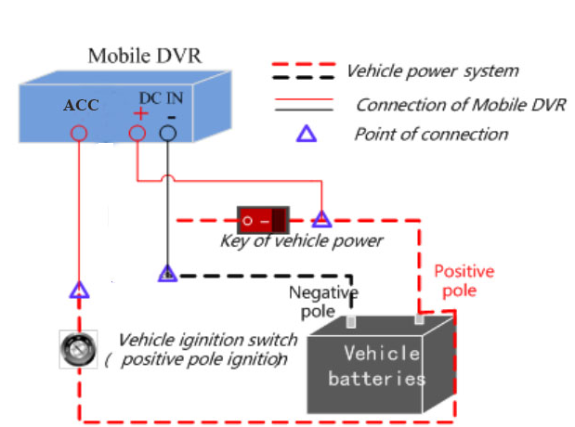

Figure 3-1 Delayed shutdown diagram

1.The "DC IN +" of the device is connected to the positive pole of the normal power supply in the car, and the main switch of the normal power supply in the car is skipped in the middle.
2.The "DC IN -" interface of the device is directly connected to the negative pole of the normal power supply in the car.
3.The "ACC" ignition switch of the device is turned off. Delay shutdown according to the configured time.
4.Connect the fuse to the fuse socket of the power cord.

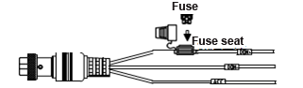

Figure 3-2 Insert fuse diagram

Note: The normal power supply in the car in the figure refers to the total power supply of the power supply system in the car. After the car is turned off, the normal power supply in the car can still provide DC power for other equipment in the car to work normally.

3.1.2 Timer switch

Figure 3-3 Timer switch diagram

1.The "DC +" of the equipment is connected to the positive pole of the normal power supply in the car, and the main switch of the normal power supply in the car is skipped in the middle.
2.The "DC -" interface of the device is directly connected to the negative pole of the normal power supply in the car.
3.When the "ACC" ignition switch of the equipment is turned off, the interface configuration can set a timing point to start up, and after reporting the work process, it will automatically shut down.
4.Connect the fuse to the fuse socket of the power cord.

Figure 3-4 Insert fuse diagram

3.2 Alarm input

When the DVR is required to perform alarm linkage for vehicle information (such as opening and closing doors, etc.), alarm input wiring and configuration can be performed.
Alarm input (ALARM IN): Connect to the vehicle's corresponding high and low level signals as DVR alarm input signals, which can be linked to the alarm output for alarm.

Note: For the function configuration of the alarm input, please refer to the " Chapter 8 Event Configuration"

3.3 Alarm output
When an event (motion detection, alarm input, etc.) occurs, it is necessary to link the alarm to the alarm, and the alarm output wiring and configuration can be carried out.
Alarm output (ALARM OUT): ALARM OUT n and ALARM OUT n # are a pair of alarm outputs, which can be connected to an alarm switch. When the voltage of the connected alarm is higher than the alarm output range value, please connect the relay yourself to protect the alarm output port.
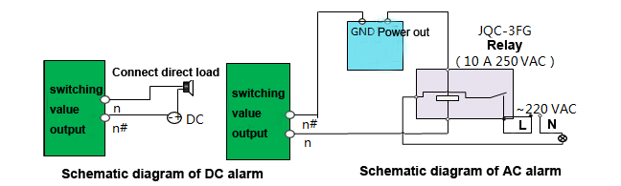

Figure 3-5 Alarm output connection diagram

Note: For the function configuration of the alarm output, please refer to the " Chapter 8 Event Configuration"

3.4 Sensor-In

When the DVR is required to link the braking, steering and reversing actions of the vehicle, the Sensor-In wiring and configuration can be performed.

1.The alarm I/O interface is connected to the extension line.
2.Connect the Sensor-In interface to the vehicle braking, reversing and steering information collection interface.

For the configuration of Sensor-In related functions, please refer to the " Chapter 6 Vehicle Configuation".

Chapter 4 System Login

4.1 System Login

Step 1: Enter user name: admin and password: admin to login system.
Access will automatically pop up the configuration wizard interface, please save the settings, and then click OK to log in to the device to perform related operations.
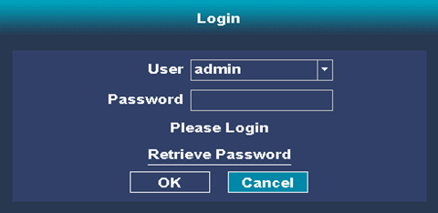

Figure 4-1 System Login

4.2 System Logout

Step 1: When entering the main interface of the device, you can right-click "Shutdown the system".
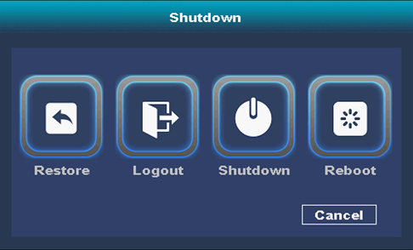
Step 2: Select "Logout" to logout system safely.

Figure 4-2 System Logout

Chapter 5 Record and Playback

When the DVR is connected to the monitor, a mouse can be connected to the USB port for local operation. This chapter mainly introduces local record and playback operations.
DVR can access analog high-definition cameras through video and audio channels for image preview, record, playback, etc.

5.1 Configuring Record

When you need to use the DVR to store the video of the connected camera, please install the storage medium(such as hard disk, SD card, etc.), format the storage medium, and configure the recording plan according to your needs.

5.1.1 Format storage device
Setp1: Click "Main Menu→Storage Management".
Step2: Select the required storage hard drive.
Step3: Click "Format".

Notice:
If you need to overwrite the video files after the hard disk is full, select "Overwrite" for circular writing. If you need to stop recording after the hard disk is full, select "Stop" for circular writing.

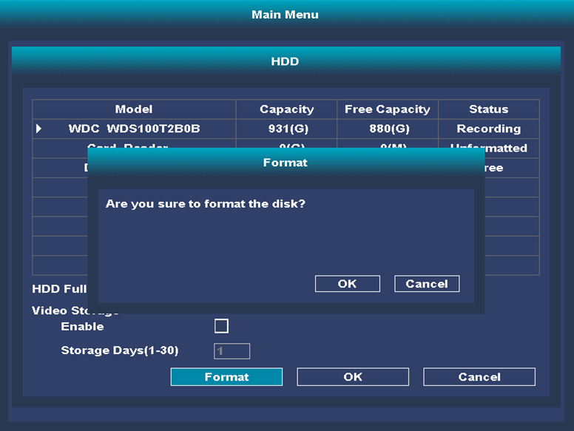

Figure 5-1 Format storage media

5.1.2 Configuring Record Plan

The DVR factory defaults to record all day regularly. After formatting the storage medium, you can directly record all day.
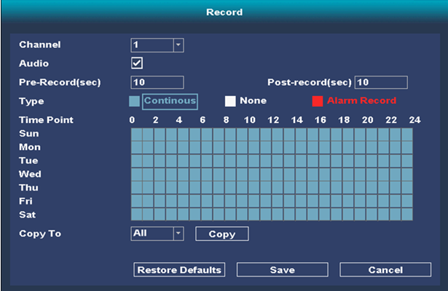

Figure 5-2 Configuration Record Plan

5.2 Playback

If you need to play back the video files in the storage medium (hard disk, SD card, etc.), you can perform the playback operation.
Enter to playback
Setp1:Click the right mouse button and select "Video playback".
Setp2:Select date, channel, full HD playback, click on the timeline. Perform playback review.
Setp3:Select the video you want to play, and click "Play".

ICON | Name | ICON | Name
 | Stop Play |  | Fast
 | Close Audio |  | Backup
 | Stop Playback |  | Cut
 | Next frame |  | Search
 | Slow |  | Full screen

Table 5-1 Playback Button

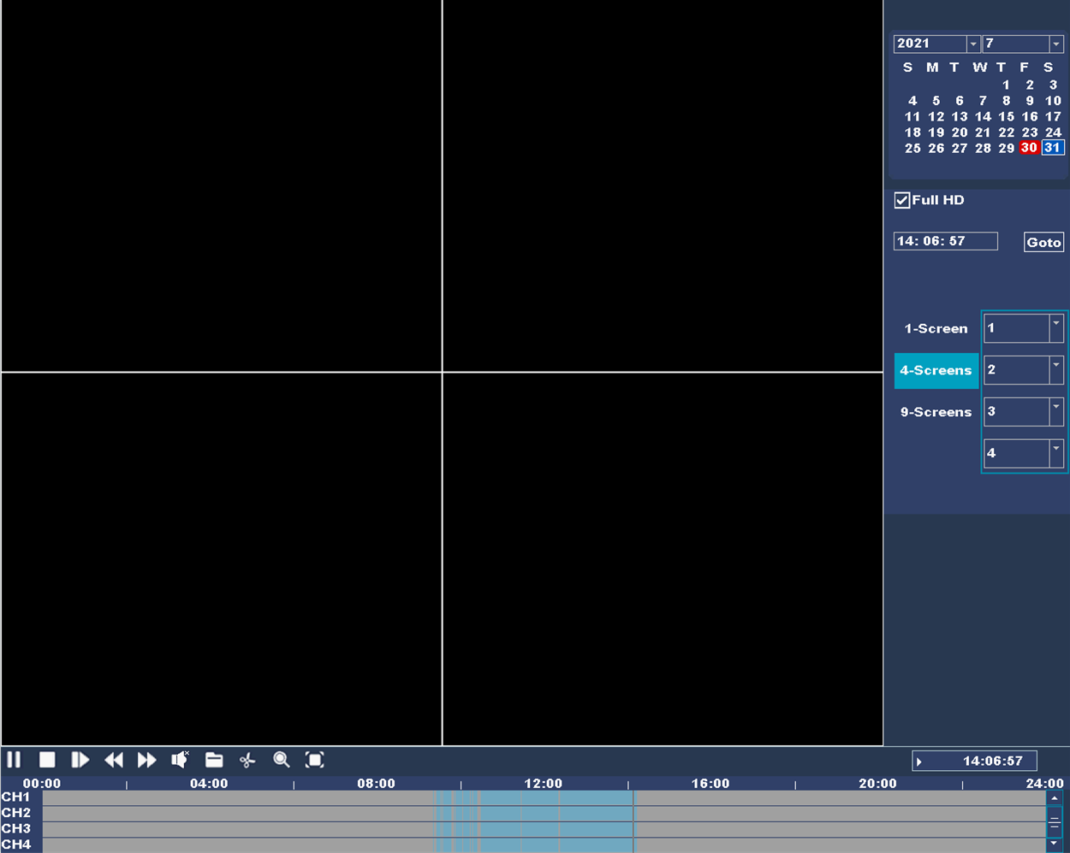
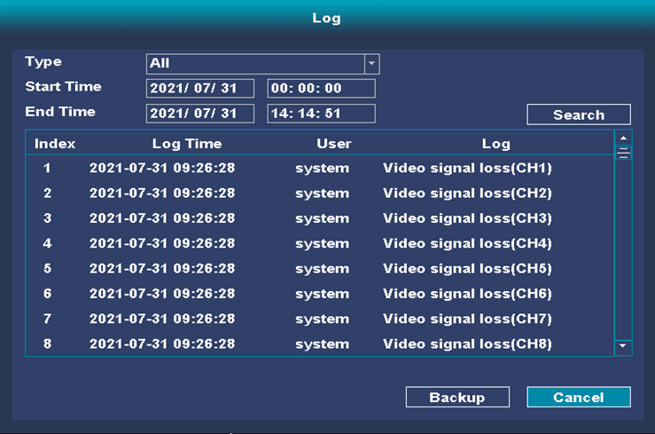
Figure 5-3 Playback Interface

Figure 5-4 Playback Log

5.3 Video Backup

If you need to back up video files, please connect a backup device to the USB interface of the DVR to perform backup operations.
If you need to format the backup device, click "Main Menu→Maintenance→Backup Media" to format.
Setp 1:Enter playback intherface
● Click the right mouse button and select "Video Backup".
● Click "Main Menu→Video Backup".
Setp 2: Select the query channel, recording start and end time.
Setp3: Click "Search".
Setp4: Select the video you want to play and click.

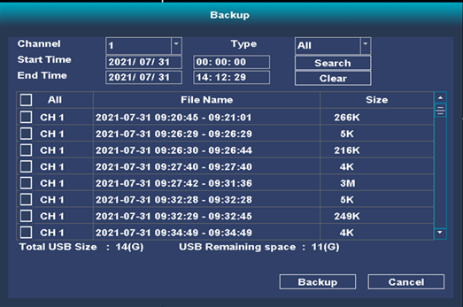

Figure 5-5 Backup

Chapter 6 Vehicle Configuation

6.1 Delayed shutdown

If you need to delay the shutdown after the vehicle is turned off, you can configure the delayed shutdown.
Setp1: Click "System Settings→Car Configuration→Start Control".
Setp2:Select the switch mode as "delayed shutdown".
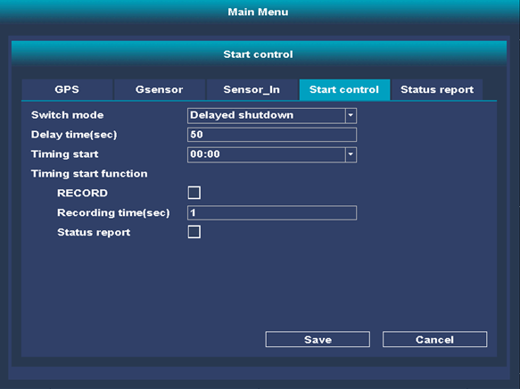
Setp3:Select the delayed shutdown time according to actual needs.

Figure 6-1 delayed shutdown

6.2 Timing start

If you need to start in a fixed time period, you can configure the timing to start.
Step 1: Click "System Settings→Car Configuration→Start Control".
Step 2: Select the "timing start" time. Configure the timing start time. When the device is in the shutdown state, the device will start to perform related operations when the set time is reached, and the operation content can be checked by the user. Its content includes video recording, status report, etc.
Notice: Supports at most one time setting.
After selecting recording, the device will start recording after reaching the set time. It will automatically shut down after recording.
Check the start server in the status report settings and configure the server address and port to report the status. The content of the report can be selected by the user. The content includes hard disk status, ACC status, GPS, startup mode, etc.
Step3: Click "Save" to complete the setting.

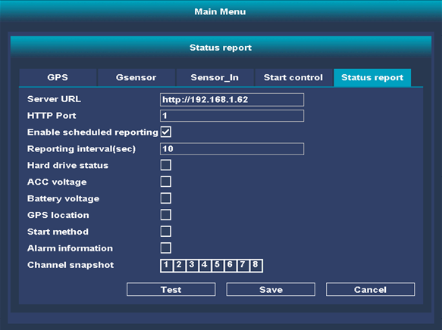

Figure 6-2 Timing start

6.3 GPS configuration

If you need to perform satellite positioning, time calibration, and speed limit alarms on the equipment, you can configure satellite positioning. Prerequisite: Please refer to the "Quick Guide" to access the positioning antenna.
Step 1: Click "System Settings→Vehicle Configuration→Positioning Configuration".
Step 2: If you need to use satellite timing, please click Step 3: "Enable". Configure speed limit alarm
1. Select the speed unit according to actual needs.
2. Enter the speed limit alarm value, and alarm linkage will be performed when the set value is exceeded. Step 4: Configure linkage mode
When the vehicle exceeds the limit value, the alarm output needs to be triggered to give an alarm by the alarm. You can check the "Linked alarm output".
For the configuration of the alarm output, refer to "7.3 Configuring the Alarm Output".
When the vehicle exceeds the limit value, the device is required to emit a "didi" warning sound, and the "sound warning" can be checked. Step 5:
Click "Save" to complete the configuration.
Step 6: Click "Positioning Status" to view specific location information.

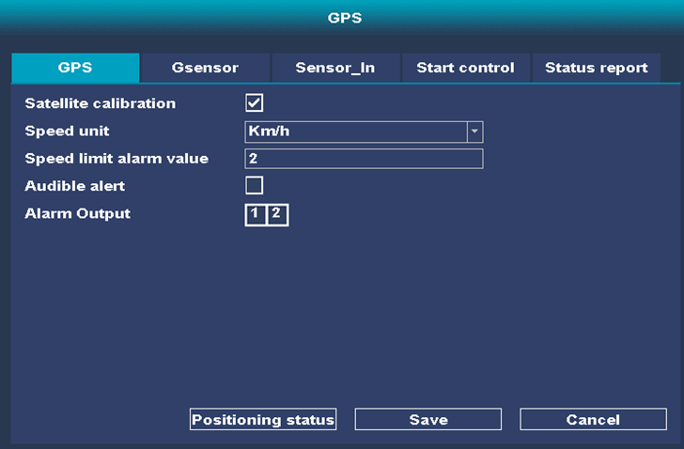

Figure 6-3 GPS configuration

6.4 Configuring G-Sensor

If you need to record vehicle acceleration information, you can configure G-Sensor.
Prerequisite: Refer to the "Quick Guide" to connect the alarm button to the relevant interface. Step1: Click "System Settings→Car Configuration→GSensor".
Step2: Select the acceleration alarm value in the three directions of X, Y and Z. When it exceeds the set alarm value range, the linkage alarm output will be triggered.
Notice: The unit of the alarm value is G (G=9.8 m/s2).
Step3: Configure the linkage mode. For details, please refer to "4.3 Configuration Linkage F-type". Select "Save" to complete the configuration.
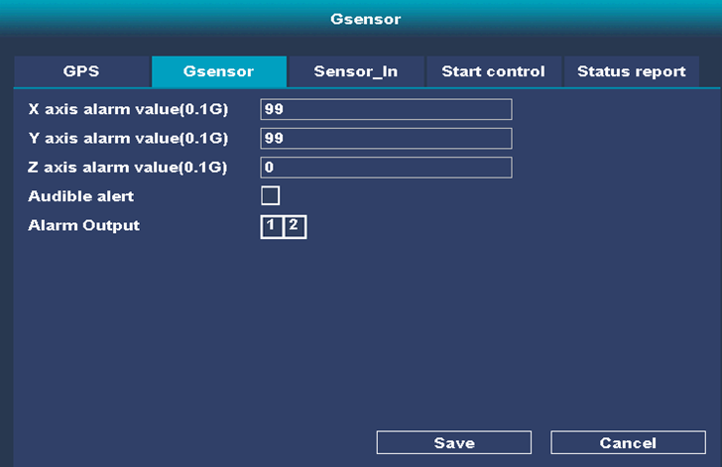

Fugure 6-4 Configuring G-Sensor

6.5 Sensor-In Configuring

Step1: Click "System Settings→Car Configuration→Sensor_In".
Step2: Select Sensor_In behavior, trigger level (selected according to actual vehicle conditions) and trigger pop-up screen.
Step3: Click "Save".
result:
When the vehicle brakes, turns, reverses, etc., the DVR display shows the pop-up channel picture.

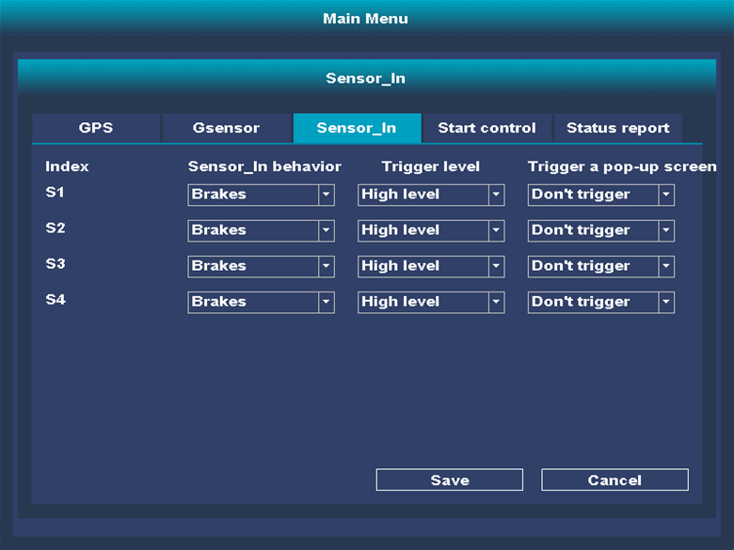

Fugure6-5 Configuring Sensor_In

Chapter 7 Network Configuration

7.1 Network Connection

7.1.1 Wireless connections

Dial
If the DVR needs to connect to the external network through dial-up, you can configure the dial-up parameters. Prerequisite: Refer to "Quick Guide" to access 3G/4G antenna.
Step1: Click "System Settings→Network Configuration→Advanced Settings→3G/4G".
Step2: Click on settings and check enable.
Step3: If you are dialing for a private network, you need to configure the dialing parameters.
1. Click "Type".
2. Select the network switching method as AUTO.
If you only need to use a 3G or 4G network, you can choose the network switching method to be 3G or 4G.
3. Consult the operator and fill in the 3G/4G dial-in number, user name, password, and APN information. Step4: Click "Save".
Step5: Click "Settings" to check the IP address changes, that is, the dial-up is successful, and you can connect to the external network normally.
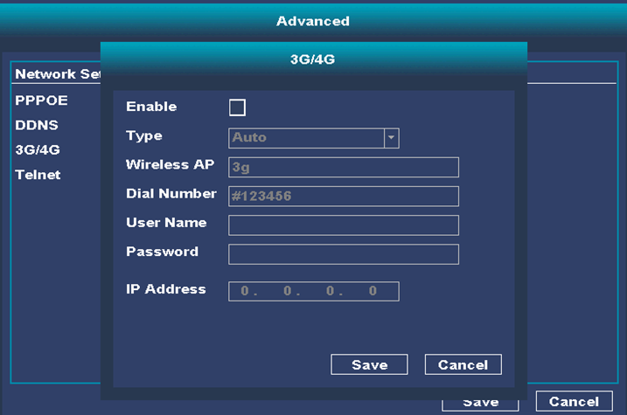

Fugure 7-1 Dial Configuration

7.1.2 Wired Connection

When the DVR is connected to the network via a network cable and the IP address needs to be modified for network access, the relevant parameters can be configured via TCP/IP.
Step1: Click "System Settings→Network Configuration."
Step2: Manually enter the relevant network parameters (IP address, subnet mask and default gateway). Click "Save" to complete the setting.
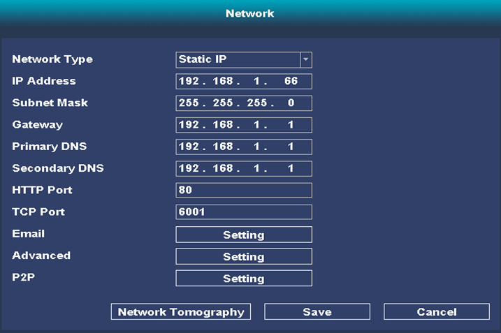

Fugure 7-2 Wired Connection

7.2 Remote access

When the remote network connection of the DVR is normal, it can be accessed remotely through the domain name.

Notice:
Device access to the Internet may face network security issues, please strengthen the protection of personal information and data security. When you find that the device may have hidden network security risks, please contact us in time. It is recommended that you conduct regular network security assessments on the equipment, and our company can provide corresponding professional technical services.
● Please understand that you are responsible for the reasonable configuration of all passwords and other related product security settings, and properly keep your user name and password.

7.3 Port Configure

If you need to view or modify the port, click "System Settings→Network Settings".
Port configuration parameters include "HTTP port" (default is 80), "T C P port" (default is 6001).
HTTP port: When using a browser to log in, you need to add the modified port number after the address.
Modifying the default port parameters at will may cause the network to be inaccessible, please modify when necessary.

Fugure 7-3 Port Configuration

Chapter 8 Channel Management

8.1 Video and Audio Settings

When you need to configure video parameters such as preview and video, you can set related parameters through "System Settings→Encoding Configuration".
The video parameters mainly include the stream type, resolution, frame rate, rate control, image quality, stream value, I frame interval and other information of the device. The interface is shown in Figure 6-1.
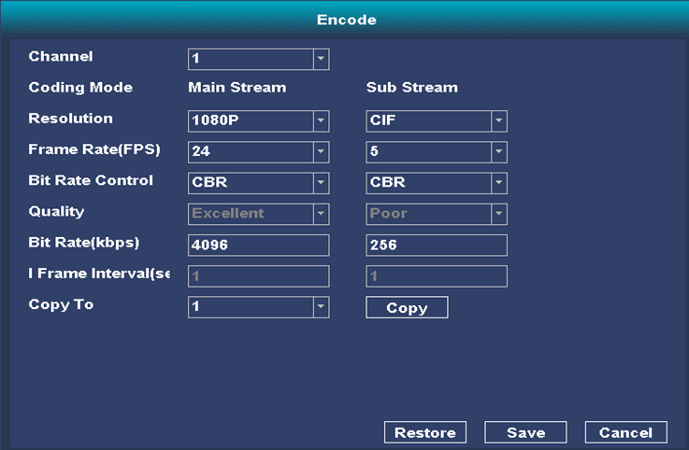

Figure 8-1 Encode
Stream type: You can set the video parameters of the main stream and sub stream. The main stream is used for high-definition storage and preview; the sub-stream is used for SD storage and preview.
Resolution: Choose according to the customer's requirements for video clarity.
Rate control and code stream value: code rate control can set variable code stream or limited code stream, limited code stream means transmission with the set fixed code stream value, and variable code stream means on the basis of not exceeding the upper limit of code stream Change on your own.
Picture quality: When the code stream is controlled as variable code stream, the picture quality can be set, which can be selected according to the customer's requirements for image clarity.
Frame rate: indicates the number of video frames per second. The higher the video frame rate, the higher the storage space required.

8.2 Display settings

The specific displayed parameters depend on the specific model of the device, please refer to the actual menu.
Click "Image Settings", the setting interface will be displayed, and the display settings mainly set the image quality of the preview screen. The setting interface is shown in Figure 6-2.
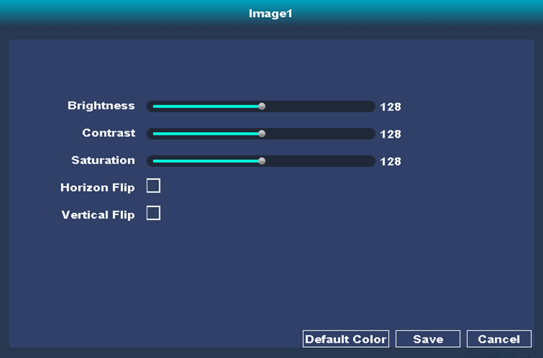

Figure 8-2 Image Settings

8.3 PTZ Settings

8.3.1 PTZ Operate
Click “” on the right side of the preview screen to show/hide the PTZ operation interface, as shown in Figure 6-3.
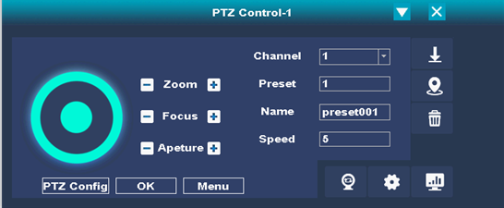

Figure 8-3 PTZ Control

Button | Direction
 | Long press the direction key to control the horizontal and vertical rotation of the pan/tilt.
 | Zoom + and Zoom -  When you hold down the “” key, the lens zooms in and the scene zooms in; when you hold down the “” key, the lens zooms out and the scene becomes smaller.
 | Represents "focus-" and "focus+".  In manual focus mode, press and hold the “” key, the nearby objects become clear, and the distant objects gradually become blurred; hold down the “” key, the distant objects become clear, and the nearby objects gradually become blurred .
 | Represents "aperture-" and "aperture+".  When the monitoring screen is relatively dark, you can press and hold "" to increase the aperture; otherwise, you can press and hold "" to decrease the aperture value.
 | Adjust the rotation speed of the gimbal, the larger the value, the faster the speed.
 | Auxiliary function buttons, the function of the function buttons depends on the specific model.  Respectively means "setup", "positioning", "delete", "start cruising", "cruising route", "high-speed pan/tilt".
 | Preset

Table 8-1 PTZ control interface button description

PTZ support functions depend on the connected PTZ, please refer to the actual interface.

8.3.2 Preset point operation

The preset point can be used to save the position information of the pan-tilt, so as to call the preset point orientation later. The specific steps of preset point operation are as follows.
The special preset point is the preset point named with the function name, not named "preset point X". The special preset point is only allowed to be called.
The support of special presets depends on the model, please refer to the actual interface.

8.3.3 Cruise scan operation

Cruise scan refers to automatic scan according to the set preset point. Each cruise path can be set with multiple points, and each point can be set with the corresponding preset point number, stay time and cruise speed.
Whether the gimbal supports cruise depends on the model.
The number of cruise paths supported by different gimbals is different, please refer to the actual interface.
Step1:Click“”。
Step2: Select the cruise path to be set, as shown in Figure 6-4.

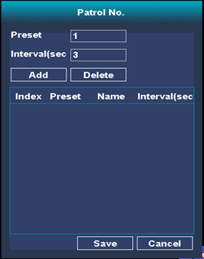

Figure 8-4 Add Cruise track

Step3:Click "" to set cruise point information, which includes preset points and interval time. You can add other cruise points in the cruise path in the same way. As shown in Figure 6-5.
Select the added cruise point and click "Delete" to delete the cruise point.

Figure 8-5 Add Preset

Step4:After setting all the cruise points, click "Save" to complete the setting of the cruise path.

Other operations

After setting the cruise path, when you select the cruise path, and you can also perform the following operations.

- Start/stop cruise: click “” You can turn on the cruise, click “” Can stop the cruise scan.
- Modify cruise path: click “” Enter the cruise path setting interface to set, the setting method is the same as the steps for setting the cruise path.
- Delete cruise path: Click "Delete" to delete the entire cruise path information.

Chapter 9 Event Configuration

9.1 Video loss alarm configuraton
When the video signal of the camera connected to the DVR is lost, a linkage alarm is required, and the video loss alarm can be configured.
Step1: Click "System Settings→Alarm Function→Video Loss".
Step2: Select the channel.
Step3: Set the arming time.
1. Click "Set Arm and Disarm Time Period".
2. Select a point on the timeline, hold down the left mouse button and drag on the timeline, and release the mouse when dragging to the end point.
Configuration linkage mode
Check the corresponding linkage mode as needed.
- When an event occurs, the alarm output needs to be triggered to alarm by the alarm, and you can choose "Linked Alarm Output".
When an event occurs, a linkage alarm output alarm is required, and the alarm output configuration can be selected.
Prerequisite: Refer to "Quick Guide" for alarm output wiring.
- When an event occurs, the device needs to emit a "didi" warning sound, and you can check the "buzzer".
- When an event occurs, an alarm screen needs to be popped up on the connected display, and you can check the "screen prompt".
- When an incident occurs, you can check FTP upload if you need to upload.
- When an event occurs, you can check Send Email when you need email reminders.
- When an event occurs, you need to record, you can choose "recording channel"
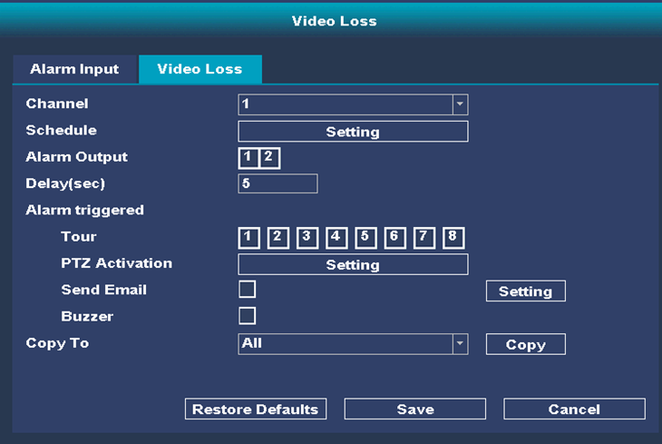

Figure 9-1 Video loss alarm Configuration

9.2 Alarm input configuraton
When the DVR is required to perform alarm linkage for vehicle
information (such as opening and closing doors, etc.), alarm input configuration can be performed. Prerequisite: Refer to "Quick Guide" for alarm input wiring.
Step1:Click "System Settings→Alarm Input".
Step2:Select the alarm type according to the access signal.
● To trigger an alarm when the line is closed, please select "Normally Open".
● To trigger an alarm when the line is disconnected, please select "normally closed".”。
Step3:Configure the arming time.
1.Click "Set Arm and Disarm Time Period".
2.Select a point on the time axis, hold down the left mouse button and drag on the time axis, and release the mouse when dragging to the end point.
Step: Configure linkage mode
Click "Linkage Mode" and check the corresponding linkage mode as needed.
- When an event occurs, the alarm output needs to be triggered to make an alarm alarm. You can check "Linked alarm output".

For the configuration of the alarm output, refer to "7.3 Configuring the Alarm Output".
- When an event occurs, the device needs to emit a "didi" warning sound, and you can check the "buzzer".
- When an event occurs, an alarm screen needs to be popped up on the connected display, and you can check the "screen prompt".
- When an event occurs, you need to upload it to enter the on-board configuration page and report it.
- When an event occurs, you need to record, and you can choose.
- Click "Save" to complete the setting.

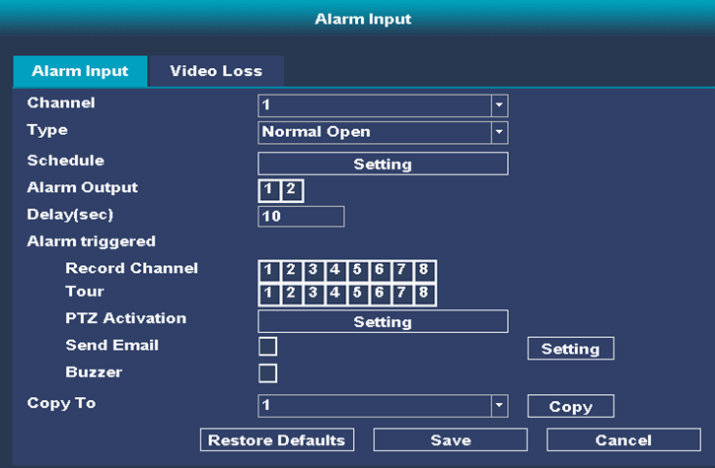

Figure 9-2 Alarm Input Configuraton

9.3 Alarm Output Configuraton

When an event occurs, a linkage alarm output alarm is required, and the alarm output configuration can be performed. Prerequisite: Refer to "Quick Guide" for alarm output wiring.
Step1: Click "System Settings -> Alarm Input".
Step2: Select the desired "Alarm Input and Output Channel".
Step3: Select the alarm "delay", when multiple alarm signals are received, the sequence will be performed, and the alarm will be output after the delay.
Step4:To configure the arming time, please refer to "Configuring the arming time."
Step5:Click "Save" to complete the setting.

Chapter 10 Security Management

In order to improve the security of data or network connection, security protection can be performed by configuring users, whitelisting and other functions.

10.1 User Management

In order to protect data privacy and restrict user access rights, user management can be performed. The "admin" user can add, modify and delete other users. The specific steps are as follows. Click "System Step1: System Settings→Security Management→Add User".
Step2:Fill in the basic information of the new user
    - Enter the username.
    - Set password → confirm password

Notice:
In order to protect your personal privacy and corporate data, and avoid network security issues on your device, it is recommended that you set a strong password that complies with security regulations.

    - Click "OK" to complete the addition of new users.
Other operations
- Click "Delete" to delete the user.
- Click "Modify" to modify the user password.

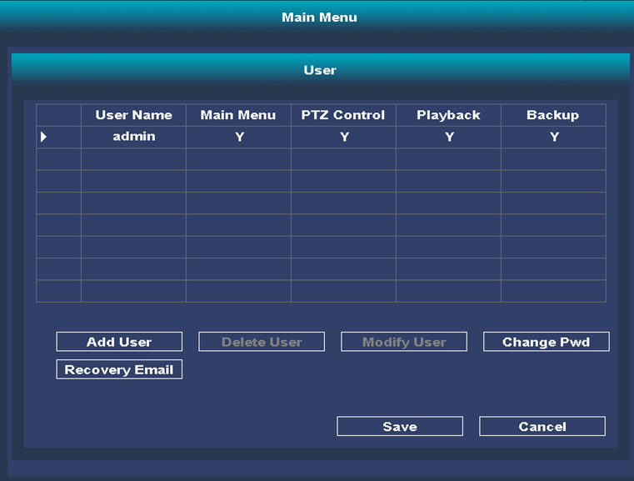

Figure 10-1 User Management

Chapter 11 Maintenance Management

11.1 View device information and logs

11.1.1 View device information
Step1: Click "System Settings→System Information→Version Information" to view the device system information.
Step2: Equipment system information includes the number of recording channels, audio input channels, serial number, system version information, serial number, alarm input and output and other information.

      - "Number of channels", "Number of audio", "Number of alarm inputs", "Number of alarm outputs" are different according to the equipment support.

11.1.2 Log query
When you need to view information such as alarms and operation records, you can find relevant information by viewing the system log.
Prerequisite: The device storage medium (hard disk, SD card, etc.) is normal before the log information can be inquired, viewed and saved normally.
Step1:Click "System Settings→System Information→Log Information" to enter the log interface, which is shown in Figure 9-1.

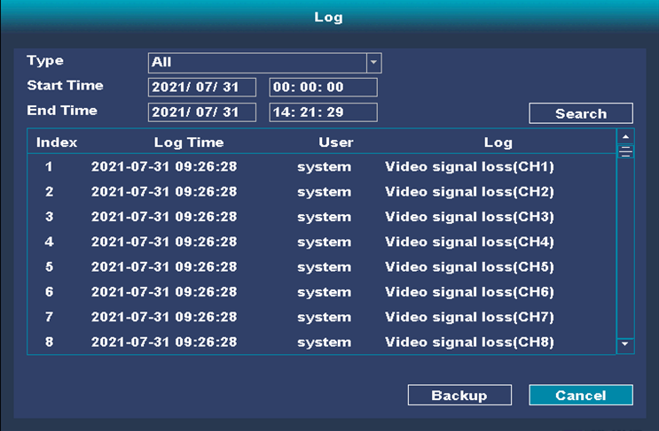

Figure 11-1 Log query

Step2:Select the log type, set the date and start and end time of the log query, click "Inquiry", and the log information that meets the conditions will be displayed in the list.
Step3:Click "Export" to save the log information to the local computer.

11.2 Upgrade, restart, restore factory settings

11.2.1 Upgrade
When the equipment needs program upgrade, you can choose offline upgrade and online upgrade.
Offline upgrade: copy the upgrade package to a USB flash drive, insert the DVR, click refresh, the upgrade package name will be displayed, click upgrade.
Online upgrade:

Notice:
Please do not turn off the power during the upgrade process, the device will automatically
restart after the upgrade is completed.

11.2.2 Restart

When the device needs to be restarted, please restart it through the software, and do not directly cut off the power. Step1: Click "Shut down the system".
Step2:Click "Restart" to restart the device.

11.2.3 restore factory settings

Step1: Click "Restore Factory Settings" and choose to restore default values.
Step2: Select all Result: Completely restore the device parameters to factory settings.
Step3: You can check the IP address, system voice, time, log information, user password, and other operations.

11.3 Time Setting

When the DVR time is wrong, the device time can be set through time calibration. Step1: Click "System Settings→Common Settings".
Step2: According to the actual time zone of the device, select "Time Zone".
Step3:Choose the school time method
- NTP time calibration
Set the NTP server address, NTP port number and time interval, and the DVR will check the time every other time according to the settings.
- Enable satellite time calibration
After select "Enable satellite time calibration" and connecting to the positioning antenna, the DVR will install GPS for time calibration.
- Daylight saving time setting
After select the "Daylight Saving Time Setting", you can adjust the date of the duration.

11.4 Resolution setting

When the DVR is connected to the monitor and the image cannot be output due to resolution mismatch and other reasons, the output resolution of the DVR can be set through the menu output to display the image normally.
Step1: Click ""System Settings→Common Settings"".
Step2: Select "Resolution" and the resolution supported by the monitor.
Step3: Complete the setting

Appendix

Abbreviations

DHCP
DHCP is the abbreviation of Dynamic Host Configuration Protocol, it is a kind of TCP/IP protocol suite, mainly used to assign dynamic IP addresses to network clients.
NTP
NTP (Network Time Protocol) is a protocol used to synchronize computer time. It can synchronize the computer to its server or clock source (such as quartz clock, GPS, etc.), and can provide high Accurate time correction (the time difference between the LAN and the standard is less than 1 millisecond, and the WAN is less than tens of milliseconds), and it can prevent malicious protocol attacks by encrypting and confirming.
G-Sensor
G-sensor (Gravity-sensor) is a gravity sensor, G-Sensor can perceive changes in acceleration, such as shaking, falling, rising, falling and other movement changes can be converted into electrical signals by G-sensor, and then through the micro The processor calculates and analyzes to complete the programmed functions. The G-Sensor application on the hard disk can detect the current state of the hard disk. When an accidental drop occurs, acceleration will occur. The hard disk senses the acceleration and the magnetic head will automatically return to position to separate the disk body and the magnetic head to prevent reading and writing operations. Suffered from unexpected shocks, thereby effectively protecting the hard disk.
Sensor-In
Sensor-In refers to the component used to record driver operation information on the device, mainly including braking, turning left, turning right, and reversing information. It can be used for analysis when an accident occurs.

FAQ

1. Alarm sound
Q:
What should I do if there is a "didi" alarm sound after the device is turned on?

A:
● Check whether the DVR hard disk is configured with an alarm buzzer or sound alarm option.
● If you don't need to install the hard disk, click "Configuration→Events→Exception", select "Hard Disk Error" and cancel the "Sound Alarm", click "Save".
● Click "Configuration → Storage → Storage Management → Hard Disk Management" to view the hard disk status. If it is abnormal, please replace the monitoring-level hard disk for testing.
2.Unable to start

Q:
What should I do if the device fails to start after it is powered on?
A:
● The power supply does not conform to the DVR power supply standard. For the DVR power supply standard, please refer to the relevant parameter table.
● The hard disk is unlocked, please use the hard disk lock key to lock the hard disk lock.
3.Network connection problems
Q:
What should I do if the dialing fails?
A:
Check whether the dial-up antenna is connected well.
The SIM card is owed or damaged.
The dial-up user name and password or APN parameters are entered incorrectly, please consult the operator.
Q:
What should I do if GPS positioning fails?
A:
● Please check whether the device model supports GPS module.
● Please check whether the GPS is installed outdoors and unobstructed.
● Please select "Configuration → Vehicle → Basic Configuration → Positioning Configuration" to check whether the parameter settings match the actual module.

4 Replay issues
Q:
What if the video file cannot be found during playback or backup?
A:
● 1.Click "System Settings→Recording Plan" to check whether the recording plan is properly configured.
● 2.Click "System Settings → Storage Management → Hard Disk Management" to view the hard disk status, if abnormal, please replace the monitoring level hard disk for testing

